The BIBDESK database:

URL / online references need harmonising throughout the whole database.
CAUTION: be careful with the URL field in general references. the style seems to extract the URLs on any reference and add them to the bibliography - desirable?

the AGSM style (although in the harvard family) has some stylistic differences to what is generally listed as harvard

constraints in ONLINE URL ELECTRONIC references.

Bibdesk Example

This entry:

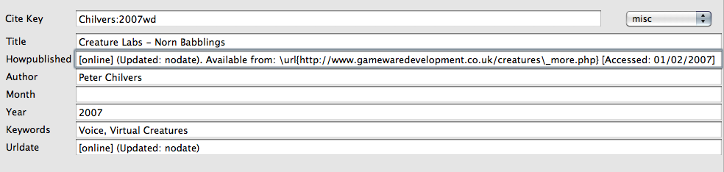

Results in:

Chilvers, P. (2007), ‘Creature labs - norn babblings’, [online] (Updated: no- date). Available at: http://www.gamewaredevelopment.co.uk/creatures_more.php [Accessed: 01/02/2007]. 8

Note: remove URL field.
Note: commas rather than periods (full stops)
Note: the UPDATED field may not be needed

Authorship or Source, Year. Title of web document or web page. [Medium] Available at: include web site address/URL(Uniform Resource Locator) and additional details such as access or routing from the home page of the source. [Accessed date].

National electronic Library for Health. 2003. Can walking make you slimmer and healthier? (Hitting the headlines article). [Online] (Updated 16 Jan 2005)
Available at: http://www.nhs.uk.hth.walking [Accessed 10 April 2005].

AGSM seems to have some stylistic differences - e.g. commas, bracketed year of pub etc.

